Course 1 Foundations of User Experience (UX) Design

網站

Here are some helpful UX design resources to keep in mind as you learn. You might even want to bookmark some of these websites on your computer to review on an ongoing basis!

* [Interaction Design Foundation](https://www.interaction-design.org/literature): A library of open-source UX design resources, including new articles published every day. There are also local [meet-ups](https://www.interaction-design.org/events/ux-meetups) (virtual and in-person) that are free to attend and open to everyone.
* [Adobe XD Ideas](https://xd.adobe.com/ideas/?sdid=61PM7WSH&mv=social&mv2=ownsoc-org): A blog curated for entry-level UX designers. You’ll find inspiring examples of great design, valuable career tips, and more.
* [UX Collective on Medium](https://uxdesign.cc/): An article platform with stories on user experience, visual design, product design, and more. Articles on Medium are written by a large variety of writers and cover a range of topics.
* [Nielsen Norman Group](https://www.nngroup.com/articles/): Research-based UX guidance, including a ton of helpful articles about the design process, research methods, and user testing, which you'll learn about later in the certificate program.

UX 4要素

For a user to have a good experience, the product needs to be usable, equitable, enjoyable, and useful.

Usability refers to the product working well and being easy to use, while usefulness refers directly to the ability to solve user problems.

UX 核心能力和職位分類

Empathy

The ability to understand someone else’s feelings or thoughts in a situation.

There are many different kinds of UX designers: interaction designers, visual designers, and motion designers.

* interaction designers: focus on designing the experience of a product and how it functions
* visual designers: focus on how a product or technology looks
* motion designers: think about what it feels like for a user to move through a product and how to create smooth transitions between pages on an app or a website.

Graphic designers VS UX designers

Graphic designers usually work on the appearance of a physical product, like an invitation or a poster, while UX designers focus on how users interact with the product.

UX團隊：

* UX researchers conduct the studies or interviews that help us learn how people use a product.
* UX writers think about how to make the language within a product clearer to make the user experience more intuitive. This could include writing labels for buttons or adjusting the tone to be formal or friendly.
* Production designers often act as a bridge between interaction designers and engineers. They make sure the first and final designs match in the finished product materials and that the assets are ready to be handed off to the engineering team. The assets are everything from text and images to the design specifications, like font style, color, size, and spacing.
* UX engineers translate the design's intent into a functioning experience, like a website or an app.
* UX program managers ensure clear and timely communication so that the process of building a useful product moves smoothly from start to finish. This might include setting up goals and writing project plans.

The product development life cycle

There are five stages in the product development lifecycle: **brainstorm**, **define**, **design**, **test**, and **launch**

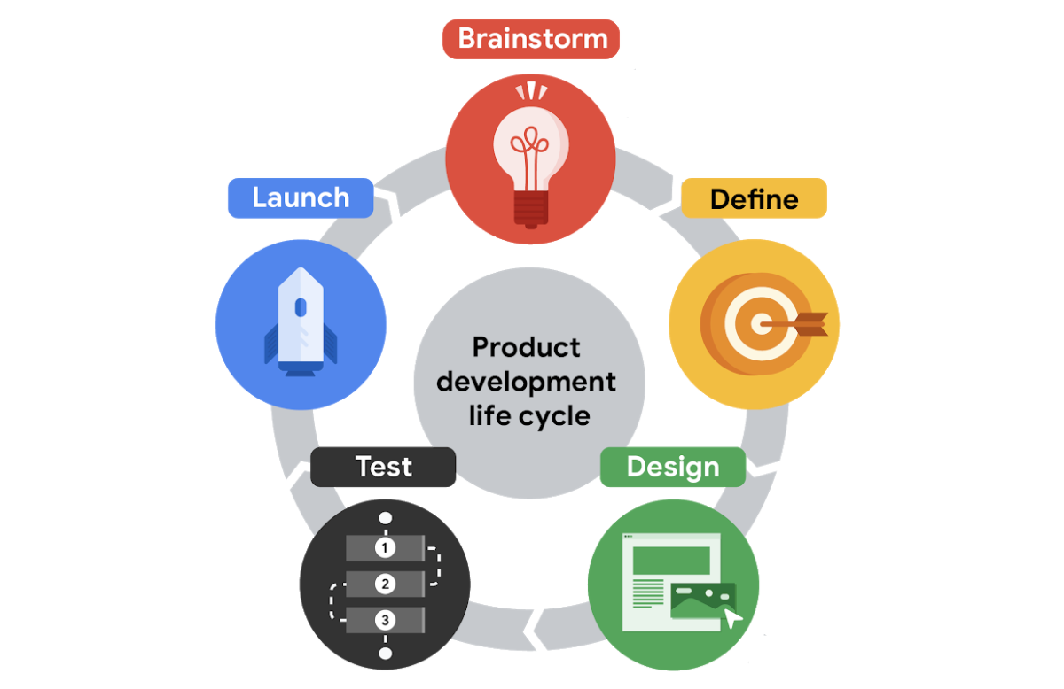

* first stage: brainstorm

active discovery stage

generating ideas about the user and potential needs or challenges the user might have

generates ideas to solve a problem

Research plays a key role in this first stage.

UX researchers and writers are often heavily involved in this stage, where the team might conduct interviews with potential users or conduct other research.

It’s important to pay attention to the diversity of your team at this stage. Teams that have meaningful diversity across identifiers like race, gender, abilities, family structure, age, and ethnicity are generally more effective at brainstorming because they bring together a lot of different lived experiences.

The brainstorm stage is also an ideal time to check out your product's competitors and identify if there are already similar products available in the market. You want your product to fill a gap in the market or solve a problem better than existing products. Completing research into both your competitors and your users helps determine what problems need to be addressed by the product’s design.

* second stage: define

Define is all about using the insights from the brainstorm stage and starting to narrow the focus. During the define stage, the team determines concrete ways that the product being developed will impact the user. As a UX designer, you'll begin to think more about specific details related to the product, who the product is for, what the product will do, and what features need to be included for the product to be successful. Statements that outline the goals or outline any problems you want to answer with the product design are the focus in the define stage.

* third stage: design

In the design stage, UX designers begin to actively develop ideas, and they also check that all specifications from the define stage are realistic. The first two stages are more about preparation and planning. They give you a clear understanding of who the user is, what the user wants, and which problems or challenges you want to address in your design. Using the insights from the first two stages, UX designers generate designs that keep the user top of mind.

You'll create many different assets, including storyboards, which are sketches that help explore the user's experience, or wireframes, which provide outlines of the content layout. Or you might create prototypes, which are models that allow UX designers to test the functionality of a design.

* fourth stage: test

In the test stage, the team evaluates the product design based on feedback from potential users. Testing designs with users is really important because it helps the team focus on the user first and foremost and the designs second. Testing helps identify areas to refine or improve the designs. It also helps UX designers consider the interactivity of the design. This is a stage that involves lots of interaction between UX designers and front-end engineers as they figure out ways to create an end product that satisfies users' needs and is practical and functional. They discuss things like how the color or font can fit the company's brand or whether the prototype designs are easily understandable.

At this stage, the designs go through at least three phases of testing: internal tests within your company, reviews with stakeholders, and external tests with potential users. A stakeholder is a person you need to work with to complete the project or anyone who has some interest in the project, either within or outside of the company.

Running these tests is typically the responsibility of the UX researcher on your team, if you have one.

* First, the team **tests the product internally** to look for technical glitches and usability problems. This is often referred to as alpha testing.
* Then, the product undergoes a **test with stakeholders** to make sure the product is aligned with the company’s vision, meets legal guidelines for accessibility, and follows government regulations for privacy, for example.
* Finally, there’s an **external test with potential users**. This is the time to figure out whether the product provides a good user experience, meaning it’s usable, equitable, enjoyable, and useful. This is often referred to as beta testing.

Gathering and implementing feedback at this stage is absolutely critical. If users are frustrated or confused by your product, UX designers make adjustments or even create new versions of the design. Then, the designs are tested again, until there’s little or no friction between the product and the user.

It’s important to call out that the product development life cycle isn’t a completely linear process. Your team might cycle between designing and testing a few times before you're ready to launch the product!

* fifth state: launch

The last state is to launch or share a finished version of the product with the public.

This might involve listing an app in the Google Play Store or Apple's App Store, making a website go live, or putting a physical product on store shelves. Launching can be very satisfying for you and your team because you have the chance to understand how your designs will be received in the real world.

However, the work on a product isn't quite finished after launch. You may still identify opportunities to improve on the designs or learn even more about the user experience based on feedback. This could involve going back to the design or testing stages and figuring out ways to produce a more enhanced version of the product.

The launch stage is a time to celebrate your work and start promoting the product. Marketing professionals on your team might post about the new product on social media or publish a press release. The customer support team might get ready to help new users learn how the product works.

Program managers also meet with the cross-functional team to reflect on the entire product development life cycle and ask questions like: What worked and what could be improved? Were goals achieved? Were timelines met? Making time for this reflection is super important, since it can help improve the process going forward.

Job responsibilities of entry-level UX designers

* researching
* wireframing
* prototyping
* creating information architecture
* communicating effectively
* research

understand audiences and learn about their backgrounds; demographics, like age and location; motivations; pain points; emotions; and life goals.

* creating wireframes

A wireframe is an outline or a sketch of a product or a screen.

It helps the designer figure out how a page is arranged, where each piece of a product fits in with the others, and how users will likely interact with the product. We can wireframe by drawing on paper or digitally on a computer.

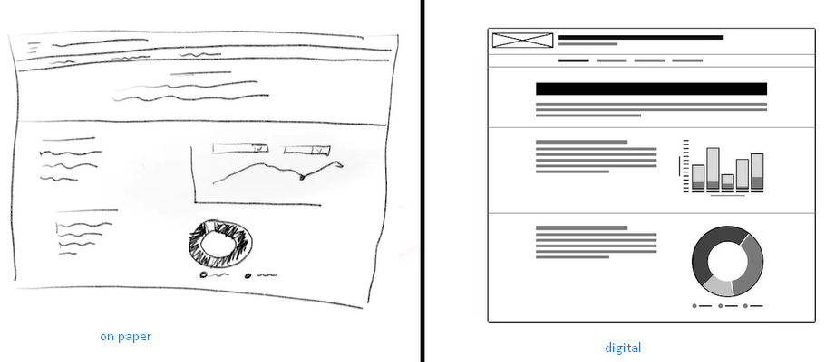

* creating prototypes

A prototype is an early model of a product that demonstrates functionality, like a wireframe, but a lot more advanced. A prototype illustrates a progression from one screen to the next. We can draw our prototypes on paper, create a physical prototype, or build a digital prototype.

* creating the information architecture

The information architecture is the framework of a website, or how it's organized, categorized, and structured. For example, when you click the File menu on a word processing application like Google Docs, you expect certain options, like New or Print, to appear in the dropdown menu. Or when you click on a company's homepage, you expect to find a link to an About page. That structure is the website's information architecture.

* communication

like meetings with colleagues, writing emails, creating proposals, or pitching clients.

Specialists, generalists, and T-shaped designers

* Generalist

A UX designer with a broad number of responsibilities

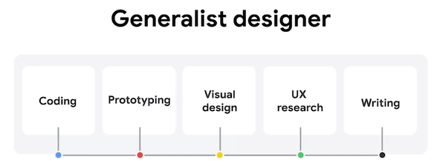

* Specialist

A specialist dives deep into one particular UX design role, like interaction, visual, or motion design

* T-shaped designer

Specializes in one kind of UX design and has a breadth of knowledge in other areas

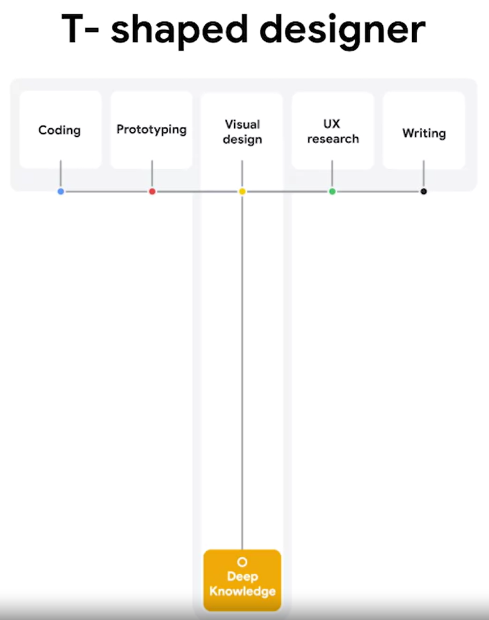

第1分工作來源

Internship

Apprenticeships

Freelancers

Entry-level jobs

UX designer僱主類別

**Startups and small businesses**

**Startups** are new businesses that want to develop a unique product or service and bring it to market. **Small businesses** are privately owned businesses with few employees. A lot of UX designers are excited to start work at startups or small businesses because they can see the impact of their work more quickly and develop a broader range of skills.



* **Team size:** Close-knit team and able to work directly with upper management.
* **Growth:** Opportunity for growth due to taking on many responsibilities (visual design, interaction design, user research, and more).
* **Creativity:** Usually more creative freedom with fewer guidelines and processes.
* **Impact:** Lots of impact on final products, with few people working on a project.



* **Mentorship:** Fewer mentors to choose from within a smaller company.
* **Responsibility:** Most of the responsibility for a UX project falls solely on you, which can be stressful if you have little UX experience.
* **Speed:** Have to be comfortable working quickly and launching work that isn’t perfect, with little oversight.

**Big companies**

At a big company, like Google, you’re likely to work in teams on a specific project. Lots of UX designers want to work at big companies with the people who developed some of the most well-known products in the world. UX teams at larger companies tend to be more compartmentalized by specialization, making it easier for you to become an expert in one particular area of UX.



* **Mentorship**: A variety of experienced designers and other UXers to learn from.
* **Growth**: Lots of opportunity for growth because there are many levels of designers and management.
* **Guidelines**: Clearer guidelines to keep products uniform and on brand.
* **Team size**: More people working on one project, which means you’re better able to focus on your specific responsibilities.
* **Specialization**: Opportunity to focus on one particular area of design.



* **Team size:** May feel less impactful or important as a contributor with lots of other designers on the project.
* **Impact:** May feel small at a company with so many features and products.
* **Guidelines:** Defined guidelines can be restrictive to creativity.

**Design agencies**

A **design agency** is a one-stop-shop for visual brands, products, and services. Working at a design agency can be similar in some ways to working at a small business or startup, except you have multiple companies as your clients. Many agencies tend to work on a broad range of products, so you can explore many kinds of styles and approaches to UX design.



* **Impact:** Lots of impact on projects, if you’re the only UX designer on the team.
* **Networking:** Opportunity to work with senior stakeholders, different teams, and diverse clients.
* **Exposure:** Exposure to lots of companies and industries with different clients.
* **Resume:** Potential to work with large brands and display that work in your portfolio.



* **Mentorship:** Lack of mentorship if you are the only UX designer on a project.
* **Monotony:** Depending on the agency, you could work only on the same type of projects.
* **Ownership:** Might not be able to work on a project from start to finish.
* **Finished product:** Products you work on might not launch, depending on client priorities.

**Advertising agencies**

A lot of UX designers work at **advertising agencies,** which are teams of creatives hired by clients to build marketing campaigns. Sometimes called “creative technologists,” these designers work to create ads for brands using UX principles. This is a great option if you’re open to learning some interesting skills outside of a core UX design role.



* **Autonomy:** Little to no middle management means more autonomy over your work.
* **Learning:** Opportunity to learn about other disciplines, like branding, marketing, and graphic design.
* **Variety:** Every project is different based on the client.
* **Networking:** Work with a bunch of different brands, clients, and teams.



* **Specialization:** Wide variation in projects, so you might not be able to hone in on specific skills easily.
* **Relevance:** Work may often involve branding and marketing, and might not focus on UX design.

**Freelancers**

**Freelancers** are self-employed UX designers who are hired by clients for their independent services. Being a freelancer gives you a lot of freedom, and it’s a great way for new UX designers to gain experience in the field and add work to their portfolio.



* **Schedule:** Set your own hours since you’re self-employed.
* **Flexibility:** Can freelance while working another job or balancing competing priorities.
* **Autonomy:** Choose the work that you want to do.
* **Experience:** Build your portfolio, especially if you don’t have a full-time UX job.



* **Structure:** No one to report to, which means you have to be responsible for getting work done on time.
* **Stability:** Less stable than working for a company or agency, since work is not always guaranteed.
* **Business:** Manage the logistics of your own business, such as filing taxes, billing clients, and more.
* **Mentorship:** Lack of readily available mentors since you’re working by yourself.

**Deciding where to work**

Everyone’s goals as a UX designer are different, so think about what’s most important to you when choosing a place to work. Consider questions like:

* Do you enjoy a lot of structure and processes, or do you like to define your own work and schedule?
* Do you value working on a big team, or are you more comfortable working alone?
* Do you want to focus mainly on UX design, or are you interested in broadening your skill set?

Considering your career goals and how you work best will help you start to figure out the kind of company that might be the best fit for you. Good luck!

Users & User Experience

In the field of user experience design, the “user” comes first.

A user is a person who is trying to **solve a problem** and is looking for a product or service to help them solve it.

The user experience is the journey that the user takes with that product or service.

As a UX designer, your goal is to keep the user at the center of every decision you make, and to do that, you need to get to know your user.

## assistive technology

The term assistive technology, or AT for short, is used to describe any products, equipment, and systems that enhance learning, working, and daily living for people with disabilities.

Assistive technologies include color modification, voice control, screen readers, and alternative text.

* **color modification**

Color modification, like high contrast mode or dark mode on a device, increases the contrast of colors on a screen. Black text on a white background, or white text on a dark background are both examples of high contrast. High contrast makes the interface easier to see for people with low vision.

Color modification also helps anyone who might experience eye strain when viewing screens in the dark or midday, when the sun is creating an intense glare.

* **voice control and switch**

Voice control and switch helps people with limited dexterity and can serve as an alternative to a keyboard or mouse. Voice control allows users to navigate and interact with the buttons and screens on their devices using only their voice.

A switch is an assistive technology device that replaces the need to use a computer keyboard or a mouse. Switch devices can allow users to control technology like a computer or smartphone. There are a lot of different kinds of switch devices, but they all help people with limited motor ability use technology more easily.

* **screen readers**

Next up, screen readers. Screen readers are one of the most common assistive technologies for people with limited vision. The software works on mobile and web devices and reads out loud any on screen text. Screen readers also read any interactive elements, like buttons, along with non visible text, like the button names, and any alternative text for images.

* **alternative text**

Alternative text, or alt text, helps translate a visual user interface into a text-based user interface. It essentially uses words to describe any meaningful image for someone who isn't able to see the image. Alt text is also super helpful for those with low bandwidth connections, too. If your device is unable to maintain a connection to the internet, it may struggle to load a big file or image. Alt text is useful for context when an image fails to load.

Design Thinking: A UX design framework

The Design Thinking framework involves the following phases: empathize, define, ideate, prototype, and test.

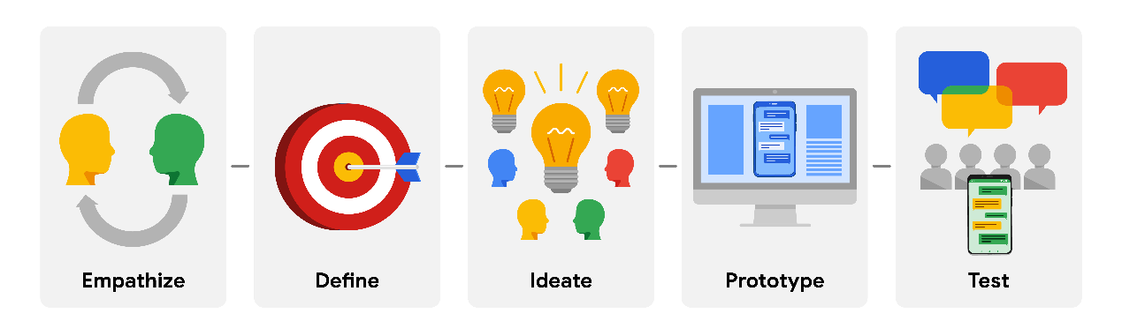

Though it may sound like a linear process, the Design Thinking framework should be iterative, which means that you’ll repeat certain phases as you refine your designs. For example, depending on the feedback you receive during testing, you might need to conduct additional research, brainstorm new ideas, or develop new prototypes.

Keep in mind that the Design Thinking framework as presented here is an idealized model for UX designers to follow, so you might see some variation in its implementation between different companies, teams, or projects.

## Empathize

During the **empathize** phase, your primary goal is to learn more about the user and their problems, wants, and needs, and the environment or context in which they’ll experience your design. The most important part of the empathize phase is to step away from your assumptions and guesses and let your research findings inform your decision-making in later design phases.

Your user research might include user surveys, interviews, and observation sessions, and you might also need to conduct some research on the competitors’ products to determine how your user frames competitors’ products as part of their daily life and daily problem-solving.

## Define

In the **define** phase, you’ll analyze your research findings from the empathize phase and determine which user problems are the most important ones to solve, and why. This will drive you toward a clear goal for the design of the product.

The most important outcome of this phase is a clear problem statement, which is a description of the user’s need that your designs will address. You might also develop a value proposition, which is a summary of why your user would or should use the product or service that you’re designing.

## Ideate

After you land on a user problem and establish why it’s an important one to solve, it’s time for the **ideate** phase. The goal of ideation is to come up with as many design solutions as possible—don’t settle for your first solution because the most obvious solution is not always the right one.

Ideation involves collaborative brainstorming with other members of your team to generate as many solutions as possible to a problem. This could include marketing, engineering, product management, or any other stakeholders for the product or service. During brainstorming sessions, you should explore all possible solutions. Don’t focus on whether something is a “good” or “bad” idea, just collect as many ideas as you can. The important thing here is to keep this process judgment-free.

After brainstorming, you’ll then analyze your potential solutions and start to make choices about which ones are the best options to pursue as prototypes. You might return to user or competitive research to help you narrow down your ideas, and you might also create user flows to illustrate how the user will interact with your solution.

## Prototype and Test

After you have an idea of how to solve the problem, you’re ready to enter the **prototype** phase, where your goal is to produce an early model of a product that demonstrates its functionality and can be used for testing. The **test** phase is critical to developing the right solution to address your user’s problem, and an organized approach to testing can help you create exceptional user experiences.

Prototyping and testing are interconnected, which means that you’ll test your designs at each stage of prototype development rather than waiting to test until after the working prototype is complete. If the design is too polished the first time you present it to users, you might not get as much feedback. Think about ways to include testing throughout the design process, so that you’re iterating your designs based on user feedback instead of other reasons.

For example, you might test the concepts behind your design by presenting users with a simple sketch, wireframe, or a sitemap. Taking what you learned, you might iterate on that design to a more detailed design on paper (known as a low-fidelity prototype) and conduct another round of user testing. At some point, you’ll iterate the design again into a working, interactive model using a software program (also known as a high-fidelity prototype) and test that as well. You might also consider testing more than one prototype at the same time to get feedback on multiple solutions, or testing the same prototype on multiple platforms, such as a laptop, tablet, and smartphone.

The goal of testing prototypes is to continue to refine the prototype as you gain insight into whether the design for your product or service is easy to use and solves the user’s problem. At some point, you’ll finalize a prototype, and then you’ll provide it to developers, who will then turn your design into a product.

## Summary

The Design Thinking framework is only one type of framework that UX designers use to organize their approach to designs, often based on the product they’re designing and the organization they’re working for. No matter which frameworks you use in your career, they all have a few core principles in common:

* Focus on the user.
* Create solutions that address the user’s problems.
* Collaborate with teammates across departments.
* Validate your designs.
* Iterate as needed to design the right user experience.

Universal design, inclusive design, and equity-focused design

## Universal design

Universal design is the process of creating one product for users with the widest range of abilities and in the widest range of situations. Think of it like a one-size-fits-all approach. Designers propose one solution for everyone.

The problem is that when you focus on creating one solution for everyone, the designs lose their effectiveness. It's often difficult to achieve any goals with your product when you have so many intended users. Even though it had the intention of being inclusive, it excluded a lot of people.

## Inclusive design

Inclusive design means making design choices that take into account personal identifiers like ability, race, economic status, language, age, and gender.

Inclusive design includes researchers and designers from traditionally excluded populations in the process, so they can provide their unique perspectives during all phases of the design process.

If universal design is a one-size-fits-all solution, then inclusive design can be described as solve for one, extend to many. With inclusive design, you solve for one type of user, and the benefit of that solution can extend to many other types of users.

Designing products, devices, services, or environments for people with disabilities is called accessibility. Accessibility is just one aspect of inclusive design.

It asks designers to focus on designing for groups that have been historically underrepresented or ignored when building products.

## Equity-focused design

Equity-focused design means thinking through all the aspects of a designed product and making sure the product is both accessible and fair to all genders, races, and abilities. Plus, the designs need to specifically consider underrepresented and excluded groups.

The goal of equity-focused design is to uplift groups that have been excluded historically.

In order to design with equity as a goal, we first need to know the difference between equality and equity. The two words sound similar, but they're actually two different concepts. Equality means providing the same amount of opportunity and support to all segments of society. In other words, everyone gets the same thing. Equity means providing different levels of opportunity and support for each person in order to achieve fair outcomes.

To better understand the difference between equality and equity, check out this illustration. The illustration on the left represents equality because every person gets the same box to stand on, but because each person has a different height the tallest person has a better view. The illustration on the right represents equity, because each person is given what they need. The shortest person is given the tallest stack of boxes to stand on.

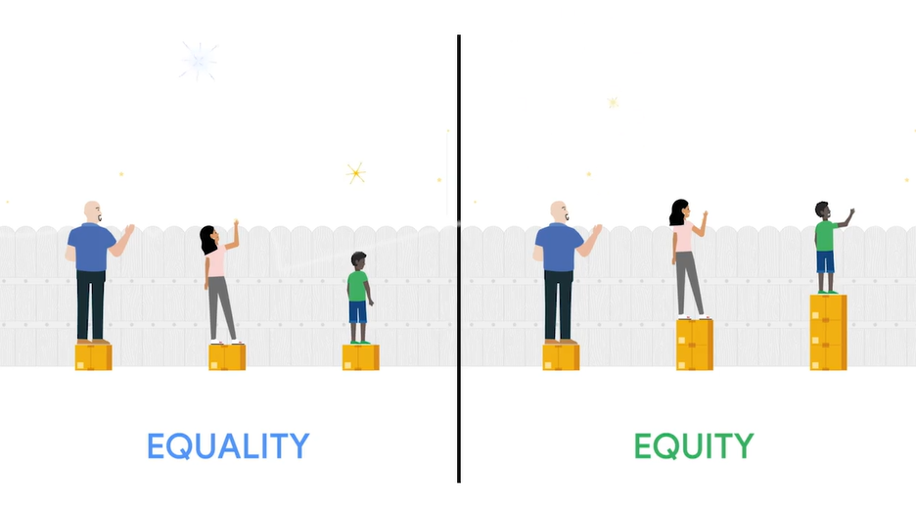

Let's explore how this relates to design. Equity-focused design is a newer concept in UX, and one that we often discuss at Google. Instead of building products for groups of people who are currently being excluded, which is the goal of inclusive design, equity-focused design seeks to build products that meet the needs of specific individuals in groups who have been excluded in the past.

Start by identifying a product you want to build. Then, think about the groups that have not been served by this type of product in the past. Finally, build your design while keeping the groups who identified as underrepresented front and center.

It's important to keep in mind that equity-focused design doesn't solve all problems, just like inclusive design and universal design don't either. The key point is that these are all different approaches to solving issues of underrepresentation and designing for a more equitable future.

These issues are massive, but vitally important. Often, schools and companies consider accessibility, inclusive design, and equity-focused design as methods to consider during the design process, but not as a requirement. But I'm a firm believer that every designer should know the basics of accessibility and why creating products for those who are underrepresented and excluded is a must.

Job applications and census forms are one area where gender and race needs specific attention, because they usually involve collecting sensitive data from users. You might have already heard about the importance of having gender neutral pronouns on these kinds of forms, but that's actually just a starting point. When designing these forms, you should also consider whether a certain question even needs to be included in the first place. Ask yourself why you're collecting this information and whether or not you really need it.

For example, a job application probably doesn't need to include a question about gender identity. If a question does need to be on the form, like in a census that's collecting population data, carefully consider the wording and make sure it doesn't have a bias toward what's considered the culturally accepted norm.

For example, imagine you have a form that asks respondents to select their gender. One form gives three choices, male, female, and other. The second form offers a wide range of choices: male, female, gender-nonconforming, nonbinary, and a blank field to allow for a written answer. The second form is much more likely to make everyone feel included, and it will also probably do a better job at gathering accurate data. Gender nonconforming means having a gender identity that doesn't conform to a society's gender norms. And nonbinary means having a gender identity that's neither entirely male or entirely female.

Another example of how equity affects gender is with public restrooms. If a business offers a men's room and a women's room, each with the same number of stalls, that would be an example of equality. However, that's not an equitable design. For one, people identifying as female often need more time, which means the bathrooms are more crowded. Plus, people who identify as gender-nonconforming or nonbinary are not included at all. Restrooms that are gender neutral, however, are an example of a physical space that's designed to treat everyone equitably. Everyone, no matter their gender identity, has the same opportunity to use each bathroom.

Let's review a few ways this has played out in the tech industry. When voice assistants were first introduced at Google, they were trained primarily with male, native English-speaking voices. As a result, the voice assistants could easily understand and respond to male voices. But they had a hard time understanding female voices, because of the higher pitch, and voices of people with strong accents. When the product launched, users were extremely frustrated when the assistant could not understand them. This example highlights how testing with a diverse set of users can truly improve a product.

Another important aspect of designing for equity is using inclusive images. Imagine you're designing an app and you need to create an illustration to use as a mock profile photo when a user hasn't added their own profile photo to their account yet. What does that illustration look like? As a designer, would you automatically create a picture that looks like you? Or would you be more inclusive in your representation? Representing diverse people through icons, illustrations, and photographs requires viewing everything we design through a critical lens. Avatars like those used in account profiles should also consider age, race, and gender, among other things. Sometimes designers consciously include an avatar that specifically challenges the mainstream image of a user for the product to be more inclusive and equitable.

Inclusive and equity-focused design are principles with endless implications and this video is just a starting point for you to build from. As we continue through the program and start discussing user research, we'll explore biases and other factors that impact equity-focused design. Coming up, we'll consider another group of users to design for: the next billion users.

Accessibility Features of Various Devices

Different device types and operating systems have different accessibility features available, and those features are updated all the time! The best way to learn about what’s available on the device you’re using right now is to check the Help. Here are a few links to get you started:

* [Google Accessibility](https://www.youtube.com/playlist?list=PL590L5WQmH8dvW6kLjd5jRDN0IiCJHLZZ) is a YouTube playlist that includes general information about various assistive technologies and how-to videos for using accessibility features in Chrome and on Chromebooks. If you’re using a Chromebook, there’s some additional guidance in the [Chromebook Help](https://support.google.com/chromebook/answer/177893?hl=en&ref_topic=9016892). If you’re an Android user, you can learn how to use accessibility features in the [Android Accessibility Help](https://support.google.com/accessibility/android#topic=6007234).
* Microsoft’s guide for [accessibility features on Windows](https://www.microsoft.com/en-us/accessibility/windows) includes descriptions of all available features, along with links to how-to content for using accessibility features on a Windows device.
* For Apple products, there’s [Get started with accessibility features on Mac](https://support.apple.com/guide/mac-help/get-started-with-accessibility-features-mh35884/mac) and the [Accessibility Support page for iPhone](https://support.apple.com/accessibility).

## Learn more about accessibility from Google

If you’re ready to learn more about accessibility, check out this three-part series from Google UX researchers about building globally accessible products.

1. [Designing for Global Accessibility, Part I: Awareness is everything](https://design.google/library/designing-global-accessibility-part-1/) outlines how you can increase your awareness of accessibility issues and check your assumptions about users.
2. [Designing for Global Accessibility, Part II: Context matters](https://design.google/library/designing-global-accessibility-part-2/) explores why it’s critical to consider logistics during the design process, in order to expand your app’s usability and usefulness.
3. [Designing for Global Accessibility, Part III: Be inclusive by default](https://design.google/library/designing-global-accessibility-part-iii/) discusses how UX designers can make tactical decisions to create inclusive apps.

You can also start to familiarize yourself with design principles that keep accessibility front-and-center by reviewing the [Accessibility Guide for Google Material](https://material.io/design/usability/accessibility.html).

Platforms

A platform is the medium that users experience your product on.

Some common platforms are:

* Desktop computers
* Laptop computers
* Mobile phones
* Tablets
* Wearables, like smart watches
* TVs
* Smart displays

A product might be experienced on countless different platforms, but desktop computers, laptop computers, and mobile phones are the most commonly used platforms for interacting with apps and websites. These are the platforms that you'll spend the most time focusing on during this certificate program.

It's important to design with multiple platforms in mind, because users want a product to look and feel similar, no matter what platform they're using.

UX designers now have to plan for a nearly infinite number of different devices and screen sizes. Even though UX designers need to think across platforms, it's important to focus on one platform first when you build a new product. The platform you select should be the one that best meets your end users' needs. Later, you can design for additional platforms.

In addition to having a consistent user experience across platforms, it's also important to have a consistent brand identity. In this case, the brand identity refers to the visual appearance and voice of a company.

It's important to keep in mind that some functionalities only exist within certain platforms.

## Platforms: Mobiles & Desktop

There's a big difference in the amount of time users spend on mobile phones compared to desktop computers. An average mobile session is 72 seconds, while the average desktop session is 150 seconds, more than twice as long.

It tells us that people use different devices in different ways. Mobile users tend to be goal-oriented, and they are focused on completing a single task. On mobile phones, gestures like tapping and swiping help users move around the screen.

## the Next Billion Users

Remember the Next Billion Users we discussed earlier? As those users come online, they're mostly accessing the internet from mobile devices. This means the amount of desktop web traffic compared to mobile web traffic will continue to shift. It's important for UX designers to consider mobile users' connectivity limitations, like slower processing speeds and longer load times. To be inclusive, we need to design for all types of phones, whether they cost $50 or $500.

* Responsiveness

In the past, most mobile websites were a mini version of the desktop site, which often made the mobile websites difficult to use. Now, almost all websites use responsive web design. Responsive web design allows a website to change automatically depending on the size of the device.

Let's think about a few best practices when designing for mobile user experiences.

* First, call-to-action buttons should be placed front and center, allowing the user to easily complete the desired task, like joining an email list or adding an item to their shopping cart.
* Second, navigation menus should be short and simple. We want to simplify the user experience on mobile. So, menu options should only highlight the core functions of the product.
* Third, use gestures that users already do, like tapping and swiping. Gestures should be intuitive and familiar to users.
* Fourth, design for both directions a phone might be held. We need to consider the vertical portrait view of a mobile phone and the horizontal landscape view. We want users to have an effective experience no matter how they hold their phone.
* Fifth, reduce visual clutter. Mobile phones have smaller screen sizes, so it's important to keep the visual experience simple.

Remember: users behave differently depending on their device.

## designing for various platforms

### Screen size

The first consideration when designing for various platforms is adjusting design elements and features to fit different screen sizes.

### Interaction

In addition to the size of the screen, you also need to consider the way users interact with each platform and how those interactions might affect your design decisions.

It’s also critical to consider accessibility when developing your designs at each point. Different groups of people will interact with your product in different ways, like using a screen reader, closed captioning, or a switch device.

To get started, it’s helpful to try using some of these technologies yourself, in order to understand how people with disabilities might interact with your product on different platforms.

### Content layout

In the world of UX design, layouts refer to the way that information is organized on the screen. For example, when designing for desktop or laptop computers, you have the advantage of working with a familiar, standardized size: landscape (horizontal) mode. The screen is wide, content can be laid out in columns, and there’s much more flexibility to design.

In contrast, mobile phone content is usually laid out in portrait (vertical) mode, which is ideal for scrolling. In addition, mobile phones often allow users the option to use landscape (horizontal) mode by rotating their device. Implementing this in your designs requires more work from you as a designer but provides users with a wider range of options.

Consider the layout of content on a couple more platforms: tablets combine both the desktop and mobile phone user experience, which means you can incorporate aspects of desktop and mobile phone content layouts in your designs. Smartwatches tend to have compact square or rectangular screens, offering very little digital real estate to lay out content.

### Functionality

There are a lot of reasons why users might choose one platform over another, but functionality and the kind of tasks they want to complete is a huge driver. Your designs for each platform will likely vary based on how and when you expect users to need the product.

design sprint

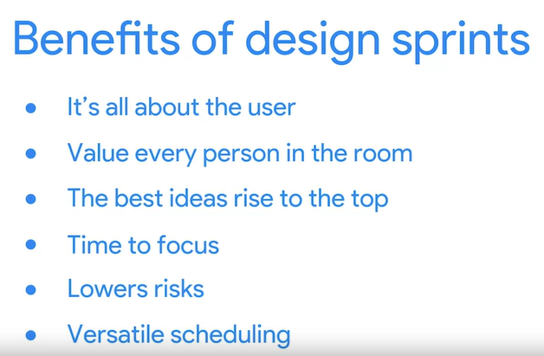

A design sprint is a time-bound process with five phases typically spread out over five full, eight-hour days.

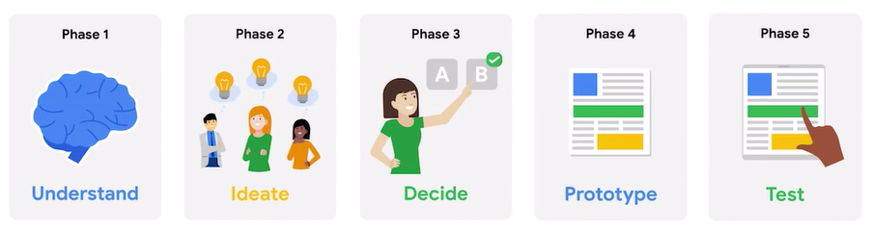

The goal of design sprints is to solve a critical design challenge through designing, prototyping, and testing ideas with users.

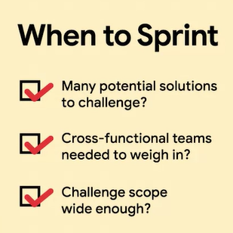

A traditional design sprint lasts five days, with each phase taking up to one full day. The whole process is super hands on. Creative collaboration is at the core of every phase.

Let's explore how a team might conduct a design sprint. Okay, imagine you're a UX designer for a company called Cycling Enthusiasts. Your latest app lets cyclists track their distance ridden and calories burned. Sadly, the app sales have started slumping. So, how can a design sprint solve this problem? Let's find out.

## Understand

The understand phase sets your sprint on the right track and helps your team get a clear picture of the design challenge.

Your team takes time to learn from experts and engage in creative discussions with a lot of different people from other departments and industries. These conversations help you more clearly understand the design challenge.

But what's the first rule of UX design? The user comes first. This means everything your team does during the sprint should focus on the user. So now your team understands the design challenge. For our imaginary sprint, let's say sales are slumping because the app doesn't offer bicyclists anything new.

## Ideate

You start this phase by coming up with ideas and building off of them to create solutions. Once you've got the team thinking, each participant takes time to sketch and present their ideas. Don't worry about your drawing skills here, the idea is what matters.

On top of all the ideating that happens in phase two, you also need to **start planning for user testing**, which happens in phase five of the sprint.

During user testing, you'll have a diverse group of people test your product and provide feedback. To be able to do this, you need to start recruiting users that fit your target profile now, so the sprint stays on schedule.

## Decide

By the time you reach phase three, you have a lot of potential solutions for your design challenge. Now it's time to decide which solutions you want to build. Together, your cycling app team discusses each possible solution, and eventually decides on the one solution that is most likely to excite users and increase sales.

For example, the solution might be a feature that uses the cyclist's location to create customized routes that meet their fitness goals.

## Prototype

Finally, you'll wrap up the day by creating a step-by-step blueprint for your prototype. You're now ready to build the first version of your new app feature. At the end of this phase, you don't need a finished product, just something realistic enough to test with users. By focusing only on what the user experiences on their screen, your team creates a working prototype of the new customized routes feature. Way to go! During this phase, you also **finish prepping for user testing** by confirming the test schedule, finalizing interview questions, and making sure your prototype is good to go.

## Test

Now it's time to put your prototype in front of users.

As users test your prototype, you observe how they react and then interview them about their experiences. Your team gains critical insight about changes that need to be made before you launch the new feature.

# Optional - Learn more about design sprints

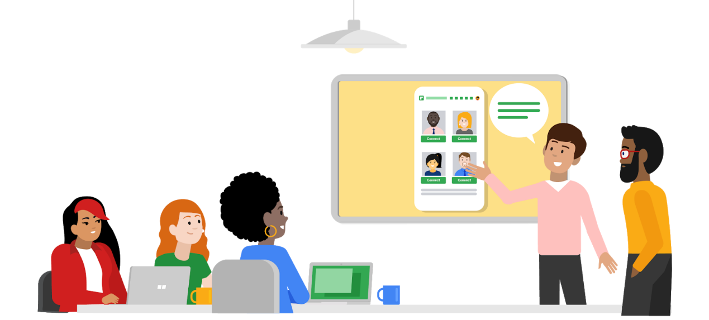

If you’re looking for a deeper dive into design sprints, why not take it up with the source? The Google [Design Sprint Kit](https://designsprintkit.withgoogle.com/) is an open-source resource for anyone who is learning about or running design sprints. The website includes [case studies](https://designsprintkit.withgoogle.com/case-studies) about design sprints that have solved all kinds of challenges, [templates for decks and activities](https://designsprintkit.withgoogle.com/resources/overview), and more.

In addition, check out this [article on Medium about the importance of design sprints](https://uxplanet.org/whats-a-design-sprint-and-why-is-it-important-f7b826651e09#:~:text=A%20Design%20Sprint%20is%20a,and%20testing%20ideas%20with%20customers.). Or, to be really inspired, read the book [Sprint](https://www.thesprintbook.com/book) by the creator of design sprints, and former Googler, Jake Knapp. Pay special attention to the chapters “Start at the End” to get an overview of how to establish long-term goals for a sprint, and “Liftoff” to motivate you to get started with your first sprint. Happy reading!

## An entry-level designer’s role

If you’re just starting out as a UX designer, you might also be curious to learn about an entry-level UX designer’s role in a sprint. We’ve got the inside scoop for you! Check out this post from the INKONIQ BLOG about [how a design sprint works at Google](https://medium.com/inkoniq-blog/inside-a-design-sprint-workshop-at-google-3950b1654f2) and this article on Medium about what [one UX designer learned from their very first design sprint](https://uxplanet.org/3-things-i-learned-from-my-first-design-sprint-ed5d2113afad).

Plan design sprints

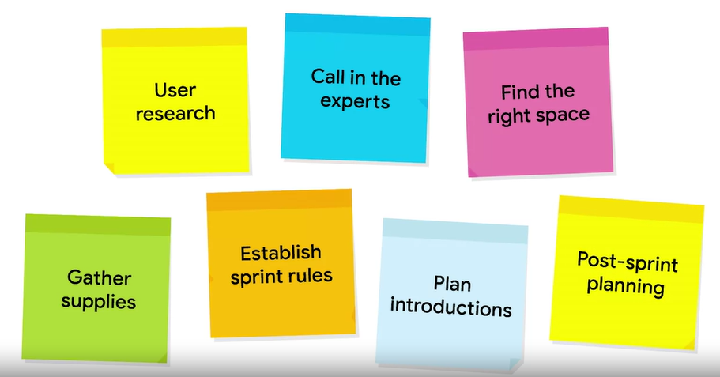

The design sprint brief

The sprint brief is a document that you'll share with all of your attendees to help them prepare for the sprint.

Example:

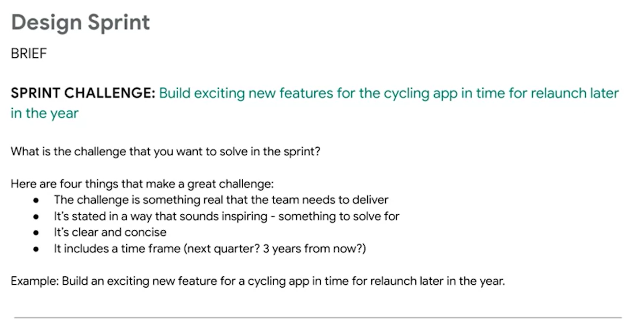

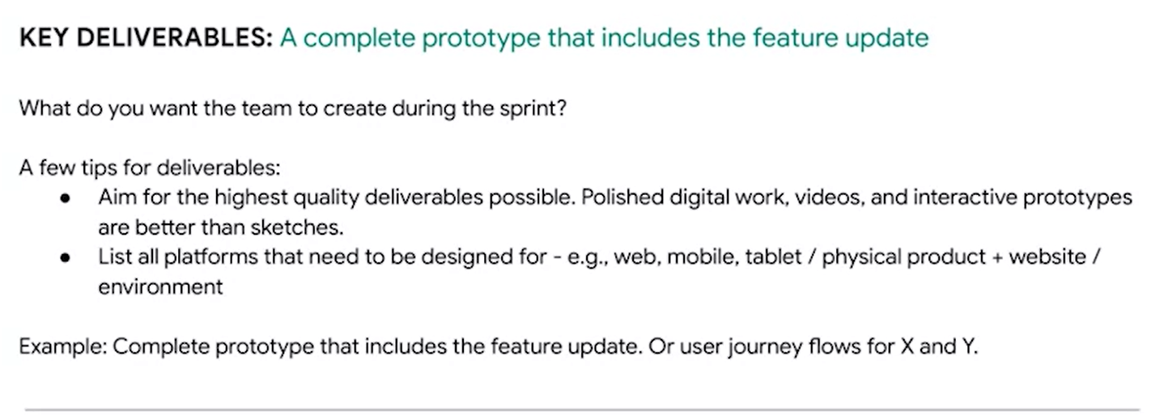

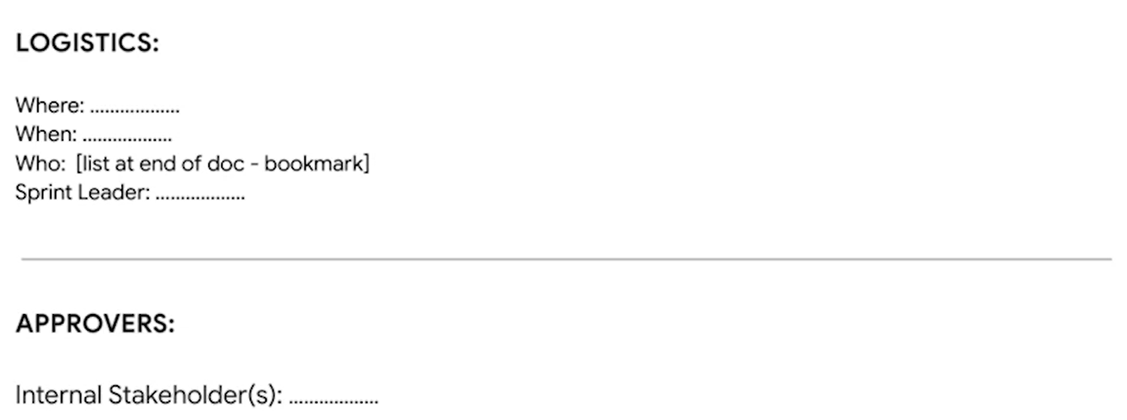

* The sprint leader is the person who sends out the brief to the team. But that's not always the case.



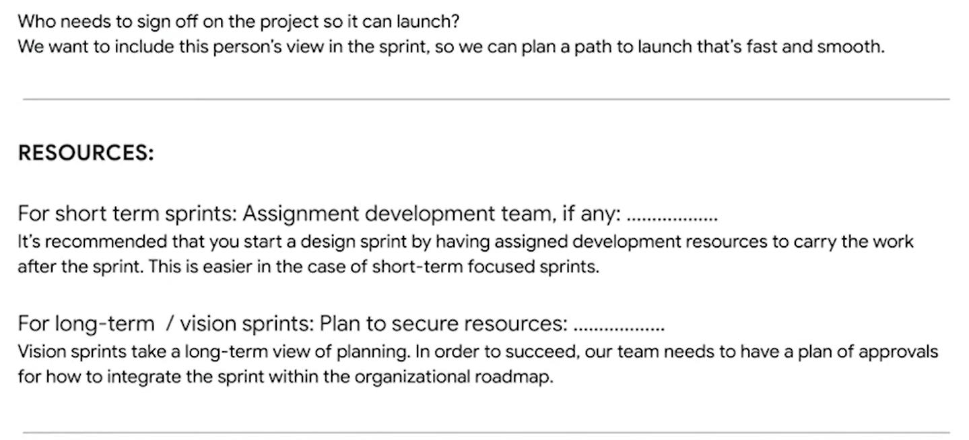

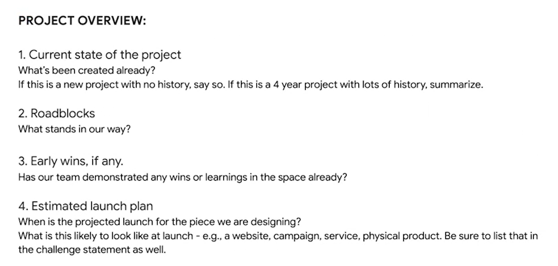

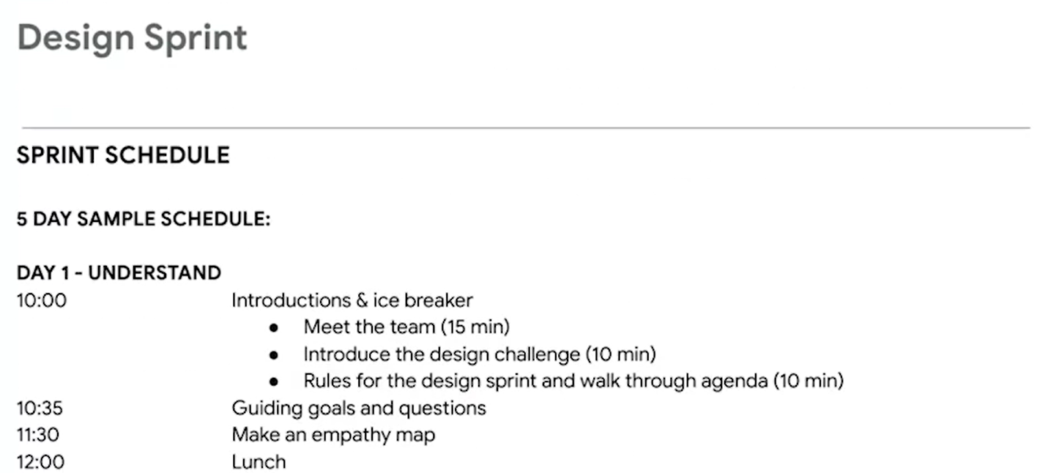

Design sprint retrospectives

The retrospective is a collaborative critique of the team's design sprint.

We usually do retrospective meetings immediately following the sprint so that everyone's thoughts are fresh.

Retrospective meetings don't have any particular agenda. The goal is to make sure everyone who took part in the sprint has a chance to give feedback.

The two key questions we aim to answer in the meeting are: "What went well?" and "What can be improved?"

The person who led the sprint will guide the conversation, and someone will take notes so that the team can use the feedback to make the next sprint even more productive.

Retrospectives are super useful. They can help you to work better as a team, improve how you communicate with clients, and even point out areas where you can grow as an individual.

Retrospectives are all about empowering, not shaming. If something didn't go well, this is your chance to make sure you have the resources and the tools to do better next time.

UX research

UX research focuses on understanding user behaviors, needs, and motivations through observation and feedback.

The **product development life cycle** has five stages — brainstorm, define, design, test, and launch — that take an idea for an app, website, or product to its launch.

Let’s check out how research fits into the product development life cycle.

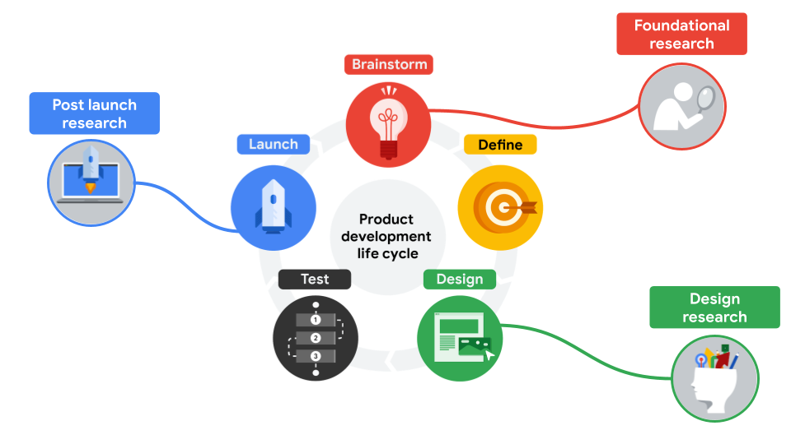

## Foundational Research

Research that takes place before anything is designed is usually called foundational research. Some UX teams might also call it strategic or generative research. All three terms mean the same thing, but in this course, we'll stick with foundational research.

Foundational research answers the questions:

* What are the user problems?
* How can we solve them?
* What should we build?
* Am I aware of my own biases, and am I able to filter them as I do research?

There are lots of research methods for conducting foundational research, but many of them are based on observations. Common foundational research methods include:

* **Interviews:** A research method used to collect in-depth information on people's opinions, thoughts, experiences, and feelings. You’ll often conduct interviews of your target users themselves.
* **Surveys:** An activity where many people are asked the same questions in order to understand what most people think about a product.
* **Focus groups:** A small group of people whose reactions are studied. For example, your focus group might bring together eight users to discuss their perspectives about new features in your design. A focus group is usually run by a moderator who guides the group on a certain topic of conversation.
* **Competitive audit:** An overview of your competitors’ strengths and weaknesses. You'll conduct your own competitive audit later in the course, so you will understand this research method well!
* **Field studies:** Research activities that take place in the user's context or personal environment, rather than in an office or lab.
* **Diary studies:** A research method used to collect qualitative data about user behaviors, activities, and experiences over time. Often, a user will log, or diary, about their daily activities and provide information about their behaviors and needs, which can help inform your designs.

## Design Research

Research that takes place during the design phase, phase 3 of the product development life cycle, is called design research. Some teams call it tactical research, but both terms refer to the same thing.

Design research answers the question:

* How should we build it?

Here's a list of things you might want to ask users about during this phase of research.

* How was your experience using the prototype today?
* How easy or difficult was it to use? Why?
* Did you encounter any challenges?

You can conduct design research very early in the design process when you have paper sketches, or you can wait until you have a prototype to test with users. It just depends on what your key research goals are.

The most common method used to conduct design research is a **usability study**, which is a technique to evaluate a product by testing it on users. The goal of usability studies is to identify pain points that the user experiences with your prototypes, so the issues can be fixed before the product launches.

Additional research methods that might be used to conduct design research include:

* **A/B testing**: A research method that evaluates and compares two different aspects of a product to discover which of them is most effective. For example, you might have users evaluate two layouts for the homepage of your app to find out which layout is more effective.
* **Cafe or guerrilla studies:** A research method where user feedback is gathered by taking a design or prototype into the public domain and asking passersby for their thoughts. For example, you might sit in a local coffee shop and ask customers if they would be willing to test your app design for a couple of minutes and provide feedback.
* **Card sorting:** A research method that instructs study participants to sort individual labels written on notecards into categories that make sense to them. This type of research is largely used to figure out the information architecture of your project, which we’ll discuss in the next course of the program — Course 3: Build Wireframes and Low-Fidelity Designs.
* **Intercepts:** A research method that gathers on-site feedback from users as they engage in the activities being researched. Intercepts are often conducted in the field, so this type of research is often considered a subset of field research. An intercept study can provide quick, high-level feedback.

## Post-Launch Research

The third type of user research is called post-launch research. Post-launch research only happens at the end of the product development life cycle. Post-launch research can be used to evaluate how well a launch feature is meeting the needs of users.

Post-launch research answers the question, "Did we succeed?"

You might also want to check your product's performance against the competition.

Research methods you might use to conduct post-launch research include:

* **A/B testing**
* **Usability studies**
* **Surveys**
* **Logs analysis:** A research method used to evaluate recordings of users while they interact with your design, tools, etc.

UX researchers’ key qualities

Qualities of a good UX researcher include empathy, pragmatism, and collaboration.

Empathy is the ability to understand someone else's feelings or thoughts in a situation.

Pragmatism is a practical approach to problem-solving. Pragmatic people are focused on reaching goals.

Collaboration is the ability to work with a range of people, personalities, and work styles.

Categorizing UX research methods

There are two ways we categorize research methods.

* The first way is based on who conducts the research.
* The second way is based on the type of data collected.

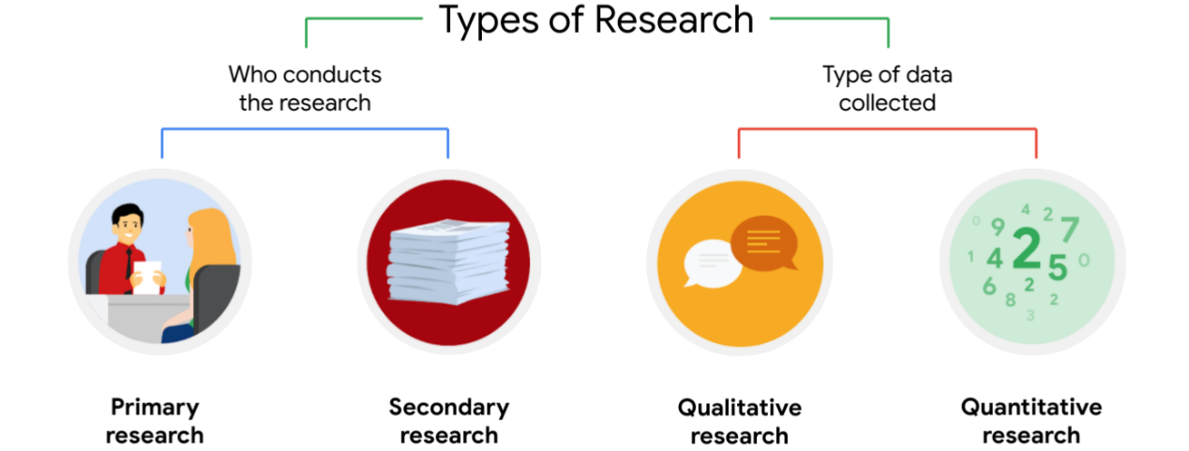

All four of these types of research can intermix. Primary and secondary research can be both qualitative and quantitative.

## The person who conducted the research

* Primary research

Primary research is research you conduct yourself. For example, you might interview users, survey users, or conduct a usability study to hear from users directly.

* Secondary research

Secondary research is research that uses information someone else has put together. Secondary research can be information from books, articles, or journals. You've probably done secondary research before and not even realized it. Looking up the statistics of a sports team counts as secondary research.

Most of the time, secondary research is done at the very beginning of the product development lifecycle, before any ideation happens.

Secondary research is often done by product leads, not UX designers. But the insights they share can help you make a stronger case for your design choices and gain more empathy for your users.

## The type of data collected

Another way to categorize research methods is to think about the type of data collected. Data can be collected through qualitative or quantitative research.

* Quantitative research

Quantitative research focuses on data that can be gathered by counting or measuring. Quantitative research is often based on surveys of large groups of people using numerical answers. This type of research often answers questions like: How many? How much? If you want to know how the majority of users are experiencing a product, you should use quantitative research.

* Qualitative research

On the other hand, qualitative research focuses on observations. Qualitative research is often based on interviews, where we focus on a smaller number of users and understand their needs in greater detail. This type of research answers questions like: Why? Or, how did this happen? If you want to know why users are having a bad experience with your product and how to improve it, you should use qualitative research.

* Telling the difference

Here's a quick way to remember the difference.

Quantitative research gives you the "what" and qualitative research gives you the "why."

Primary research methods

Now that you understand the different types of research, let’s review some common primary research methods for gathering information.

## Interviews



**Interviews** are a research method used to collect in-depth information on people's opinions, thoughts, experiences, and feelings. Interviews can be performed one-on-one or in a group setting, like a focus group.

Interviews can take the form of qualitative and quantitative research. A qualitative research method includes open-ended questions that require participants to explain their answers by providing more details. A quantitative research method includes only close-ended questions, like questions that require only “yes”  or “no” responses or set multiple choice questions.

Best practice is to conduct at least five user interviews during your research. As you conduct your interviews, you’ll start to find similarities in the feedback that users provide about what works and what doesn’t work about your product. This is exactly the kind of feedback you want!

### Advantages

* You’re better able to understand what a user thinks and why.
* You can adjust your questions or refocus the discussion based on the user’s answers.
* You have the ability to ask follow-up questions in real time.
* You have the ability to ask questions specific to a user’s needs.
* You’ll receive direct suggestions from the user.

### Disadvantages

* It’s time-consuming to interview each user.
* It’s expensive to pay participants and to rent space for the interviews.
* The sample sizes are smaller, due to time and money constraints.
* Group interviews can be affected by the effect, or going along with the group’s opinion instead of thinking creatively, which can discourage open discussion by people who have an opinion that doesn’t align with the majority of the group.

If you want to learn more about interviews, check out [an article about user interviews](https://www.nngroup.com/articles/user-interviews/#:~:text=Topics%3A,of%20learning%20about%20that%20topic.) from the Nielsen Norman Group.

## Surveys



A **survey** is an activity where many people are asked the same questions in order to understand what most people think about a product. Surveys are a great way to measure the success of your product, during development and after it’s launched. For example, sending surveys after a product is released can help you measure the effectiveness of your product and provide a foundation for future improvements.

You can design surveys to include open-ended questions for qualitative research, which allow research participants to clarify their survey responses, as well as close-ended questions for quantitative research, which generate numerical data.

### Advantages

* You can learn more from a larger sample size.
* You are able to gather results and insights quickly.
* Surveys are usually inexpensive because they don’t take as much time for participants to complete, and they can be done remotely.

### Disadvantages

* Surveys often do not allow for in-depth feedback; most questions will have responses drawn from a set of multiple-choice answers.
* There are some types of research questions that won’t work in a survey format.
* Surveys usually do not allow for personalization.

If you want to learn more about surveys, check out usability.gov's [article about online surveys](https://www.usability.gov/how-to-and-tools/methods/online-surveys.html).

## Usability Studies



A **usability study** is a technique used to evaluate a product by testing it on users. Usability studies help demonstrate if a product is on the right track or if the design needs to be adjusted. There are lots of ways to test usability, both in person and online. It’s a good idea to record your usability sessions, either audio or video, so you can reference the user data as you make design decisions later on in the process.

Qualitative research is based on observations, and a critical part of conducting usability studies is observing how participants interact with the product you’ve designed. Focusing on qualitative research during usability studies can generate more personal insights by assessing the behavior of users as they experience the product. Quantitative research can also be used when conducting usability studies to understand participants’ impressions of the product.

### Advantages

* You can learn from first-hand user interaction and observation.
* Usability studies can challenge your assumptions about your product by demonstrating a completely different result than you were expecting.
* Users can provide in-depth feedback.

### Disadvantages

* Usability studies only measures how easy it is to use a product.
* This type of research can be expensive, especially if it’s conducted in person.
* There can be differences between a “controlled” usability study in a lab versus how a user experiences the product in their real life.

If you want to learn more about usability tests, check out the Nielsen Norman Group's [article on usability testing](https://www.nngroup.com/articles/usability-testing-101/).

Secondary research methods

Secondary researchcan be completed at any phase of the project, since you’re using information from outside sources. In other words, secondary research is not a direct result of your product or the user you’re designing for. The information you discover during secondary research might lay a foundation for your primary research, so you have a better idea of where to focus your efforts. Or, secondary research might supplement the findings from your primary research for a project, to reiterate or strengthen your conclusions.

### Advantages

* Secondary research is generally cheaper and faster than primary research. This means you’ll save time and money.
* You can often find secondary research via online searches and subscription research publications.
* Secondary research can be a good supplement to findings from your primary research.

### Disadvantages

* You will not learn from any first-hand user interaction.
* You will not receive user feedback specific to your product.
* Secondary research can be misleading and generalizing if not done appropriately.

If you want to learn more about secondary research, check out [an article about secondary research](https://www.formpl.us/blog/secondary-research) from Formplus.

More information about research methods

If you want to explore research further, check out [this user-experience research methods article](https://www.nngroup.com/articles/which-ux-research-methods/) from NN Group. It will guide you through choosing the best research method for you out of 20 popular options.

Bias

A bias is favoring or having prejudice against something based on limited information. It's like making up your mind about someone before you've really gotten to know them.

6 kinds of biases:

1. confirmation bias,
2. false consensus bias,
3. recency bias,
4. primacy bias,
5. implicit bias,
6. sunk cost fallacy

## confirmation bias

This bias occurs when you start looking for evidence to prove a hypothesis you have.

Because you think you already have the answer, you're drawn to information that confirms your beliefs and preconceptions.

Let's say you have the preconception that left-handed people are more creative than right-handed people. As you research, you'll tend to gravitate toward evidence that supports this belief, and you'll use it to build your case, even though it's not necessarily true.

One of the most effective methods for overcoming confirmation bias during research is to ask open-ended questions when conducting interviews. An open-ended question lets the person being interviewed answer freely, instead of with a yes or no. You also want to get into the habit of actively listening without adding your own opinions. That means you aren't leading your interviewees toward the answer that you want them to give.

Another way to avoid confirmation bias is to include a large sample of users. Make sure you're not just looking for a small group of people who fit your preconceived ideas. You want to have a big sample of users with diverse perspectives.

## false consensus bias

It is the assumption that others will think the same way as you do.

In UX research, the false consensus bias happens when we overestimate the number of people who will agree with our idea or design, which creates a false consensus. It's possible for the false consensus to go so far as to assume anyone who doesn't agree with you is abnormal.

You can avoid false consensus bias by identifying and articulating your assumptions. For example, you might live in a community that often identifies with certain political beliefs. When you meet a new person, you might assume they share your political beliefs, because you both live in the same town. But that isn't necessarily true. Finding a few people who do align with your beliefs and assuming they represent the entire community is a false consensus. That's another reason to survey large groups of people.

## recency bias

That's when it's easiest to remember the last thing you heard in an interview, conversation, or similar setting, because it's the most recent. When talking to someone, you're more likely to remember things they shared at the end of the conversation.

To overcome the recency bias, you can take detailed notes or recordings for each interview or conversation you have. This way, you can review what people said at the start of the conversation in case you don't remember.

## primacy bias

UX designers may also struggle with primacy bias, where you remember the first participant most strongly. Sometimes the first person you meet makes the strongest impression, because you're in a new situation or having a new experience.

The primacy bias, like the recency bias, is another reason to take detailed notes or recordings, so you can review everything that happened, not just the memorable first impressions.

Recency and primacy biases also demonstrate why you should interview each participant in the same way. Consistency makes it easier to compare and contrast over time. Consistency makes it more likely that you'll remember the unusual and important moments that happen throughout your research.

## implicit bias

Implicit bias is also known as unconscious bias. Implicit bias is a collection of attitudes and stereotypes we associate to people without our conscious knowledge.

One of the most common forms of implicit bias in UX is when we only interview people within a limited set of identity profiles, such as race, age, gender, socioeconomic status, and ability. These profiles are generally based on assumptions we have about certain types of people. For example, implicit bias might cause you to feel uncomfortable interviewing people whose life experiences are different from your own.

On the other hand, we might choose to interview people from typically excluded groups, but then ask potentially offensive questions because of our internalized stereotypes.

Both of these scenarios are problematic and lead to a lack of representation in our research and design process.

The most important thing to note about implicit biases is that everybody has them. To overcome our biases, we can reflect on our behaviors, and we can ask others to point our implicit biases. That's one of the best ways we can become aware of our biases.

## sunk cost fallacy

This is the idea that the deeper we get into a project we've invested in, the harder it is to change course without feeling like we've failed or wasted time.

The phrase "sunk cost" refers to the time we've already spent or sunk into a project or activity.

For example, you might think to yourself, I might as well keep watching this terrible movie because I've watched an hour of it already.

For UX designers, the sunk cost fallacy comes into play when working on a design. You might have invested hours into designing a new feature, but then learned that the feature doesn't really address a user problem. It's easy to keep working on a design that you've invested time into. But ultimately, you need to focus on work that positively impacts users.

To avoid the sunk cost fallacy, break down your project into smaller phases, and then outline designated points where you can decide whether to continue or stop. This allows you to go back based on new insights before the project gets too far along.

Fight against bias

## Preventing bias in data collection

It’s important to note that everyone has biases. It’s just a natural part of being human. Being able to recognize your own biases and prevent them from affecting your work is what really matters. As a UX designer, you’ll need to know how to anticipate, identify, and overcome biases in your research, in particular.



### **Remain open minded**

One more tip: When you’re conducting research, you have to work hard to treat all information equally to avoid both **primacy bias,** which is remembering the first user more than others, and **recency bias**, which is most easily remembering the last thing you heard. To help combat these biases in your own research, it’s helpful to space out the scheduling of interviews, ask your colleagues to join you during interviews to provide additional opinions, and take careful notes.

### **Foster independent thinking**

Group interviews can be affected by the **bandwagon effect**, or going along with the group’s opinion instead of thinking creatively, which can discourage open discussion by people who have an opinion that doesn’t align with the majority of the group.

For example, imagine you’re conducting research with a group of five participants. You ask each person in the group to share their thoughts one at a time about a particular product design choice, like the placement of a button on the home page. By the time the last person shares their thoughts, their feedback will be affected by all of the answers that were shared before them. To combat the bandwagon effect, ask participants to write down or record their thoughts before discussing as a group.



### **Plan your research effectively**

Tight deadlines are inevitable. But as a UX designer, it’s essential you get enough time to recruit the right users for your research. **Availability bias** occurs when you rush the user recruitment process or skip screener questions to attract a bigger pool of users, even if they don’t fit the qualifications or characteristics that you’ve already determined are present in your ideal user.

The research that you collect is vital to your product design process. So interviewing users that don’t fall under your personas won’t give you the data you need to improve your designs. If you’re having trouble recruiting the right users before your deadline, offer a better incentive for participating in your study, adjust your recruitment strategy, or ask your project manager for more time. Don’t just take any user who’s available.



### **Limit the guidance you give users**

Everyone learns and thinks in different ways. When you’re conducting any type of UX research, you have to be cautious to avoid experiencing any **false consensus**, which is the assumption that others will think the same way as you do.

If you’re conducting a usability study, some of the participants will not follow the product’s user flow in the way that you might expect. For example, a user might click through the menu, select a folder, and then select a subfolder to complete a task you assigned them, when there’s actually a simple hyperlink on the homepage that could have saved them time. In addition, some participants may use assistive technology to navigate the product and might follow an entirely different flow.

It’s important to let participants follow their own paths through your product, without interrupting them. Interrupting a participant while they’re experiencing your product will deprive you of useful data that can help you understand how to improve your designs. Instead, ask participants to narrate or break down their user journey with your product, as they move through the flow. This will allow you to better understand their thought process as they navigate through your designs.



### **Choose your words carefully**

While conducting research, it’s important to use words that don’t lead the user in one direction or another. Of course, as a designer, you’re going to be partial to the designs you’ve created, and you’ll likely assume that users will appreciate them too. That’s why you designed them! But when asking users questions about their experience using your product, you don’t want them to answer in a particular way just to please you. Choosing leading words can cause the **framing effect**, where users make a decision or choice based on the way information was presented to them.

This is especially critical in usability studies. For example, imagine a participant is testing your designs. You ask the participant: “Do you like or dislike the improved layout of these buttons?” Because you used the word “improved,” the user will most likely reply positively. But, this isn’t very useful feedback because you framed the question in a way that led the participant to respond accordingly. To improve your product, you need honest feedback.

Instead, a better way to frame the same question is: “Explain how you feel about the layout of the buttons.” This phrasing allows the user to come to their own conclusions without any outside influence, which will give you better data about their thought process and experience.



### **Avoid specific language**

It’s important to be mindful about the types of questions you ask users and how those questions are framed. You’ll need to be careful to avoid **confirmation bias,** which is trying to find evidence to prove a hypothesis you already have.

Confirmation bias is particularly prevalent in online surveys. For example, imagine that you’re conducting an online survey with a large group of participants. One of your survey questions is: “How do you use our product?” As the designer, you have a few ideas about how you think people use your product, so you provide four options with specifically worded language that the participant has to choose from. If none of the options you’ve provided apply to the user, they can’t select “other” or skip the question, so they’ll be forced to choose one of the multiple-choice answers that doesn’t match their actual experience. That means you’ll end up with false information that skews your research data and potentially provides incorrect evidence for a hypothesis you already had.

Remember, in a survey, you want measurable results, which is known as quantitative data. You can reframe the question in your survey to ask participants to rate their experiences using the product, which will be a more accurate way to gauge how they felt about using it.



### **Be careful of your own body language and reactions**

You also have to be mindful of your own tone and body language while interacting with participants. **Social desirability bias** can happen when a participant answers a question based on what they think you want to hear. If you ask a question to a participant, and they notice you exhibiting a visual or audible clue that suggests your own opinion about the question, they might answer in a way that they think will please you.

For example, imagine you’re describing a feature of the app you’ve designed that really excites you, and your tone of voice changes. If this happens, it’s likely that the participant won’t be honest about their negative opinions of the feature, since you’re so positive about it. If you want the data you collect to be useful, the user has to feel comfortable sharing their true, unfiltered feelings about the product. It’s your job to guide them through the process without accidentally influencing their answers. One way to do this is to reassure participants that their answers won’t hurt anyone’s feelings and that you really want to hear their honest opinions in order to improve your work.



### **Consider users’ tone and body language**

You’ll work with many different users and participants throughout your UX career, and part of your job will involve interpreting their nonverbal cues, like vocal tone and body language. To avoid experiencing **implicit biases**, which are based on the collection of attitudes and stereotypes you associate with people without your conscious knowledge**,** it’s important to clarify when you think you’re getting mixed signals from a participant.

For example, imagine you’re conducting a one-on-one interview, and the participant has their arms crossed over their chest. This can be interpreted as a sign of feeling defensive or insecure, which might contradict the positive feedback they are sharing verbally about your product. This is a great time to ask the participant questions, like “Is any of this making you uncomfortable?”, which can encourage them to explain that it’s cold in your office and they’re just trying to warm themselves up. Always ask questions if you’re unsure about the intention of a user’s tone or body language!

For this feedback process to work, however, it’s important to make sure participants are comfortable sharing their thoughts with you. Before the research begins, ask participants about themselves or make light conversation. Starting with easier questions can help reduce anxiety or awkwardness throughout the study.



## Combating bias as a UX designer

Although having biases is normal, it’s essential to try to eliminate bias from your research process to get the most accurate understanding of your users’ needs.

Knowing the types of biases that exist and how you can avoid them will help you recognize when it’s happening, so you’re already off to a great start!

If you’d like to learn more about biases in UX research, check out [this article on overcoming cognitive bias in user research](https://npr.design/overcoming-cognitive-bias-in-user-research-e4082f4506a)from Design at NPR.

——————————————————

Course 2 Start the UX Design Process: Empathize, Define, and Ideate

Giving and Receiving Feedback

Iterating on a design using feedback is an integral part of effective UX design.

In this certificate, peer reviews are much more than just graded assignments. This practice of providing and receiving feedback is an important skill that you'll need in your work as a UX designer. This is where you will practice giving and receiving feedback like a UX designer.

You've already learned that effective UX begins with collaboration and research. The best way to think of the peer review process is as practice for future collaboration with members of your UX team in the workplace.

As you think about giving and receiving peer feedback keep in mind that future employers will be interested in seeing how you receive feedback and implement that feedback into your designs.

Here's how you can leverage what you know in our learning to be an effective peer reviewer.

* Understand the activity

Understand the activity, this should always be your first step. You have to understand the concept of the activity before you can explain how a peer's work can be improved. It's a recommended best practice to complete the activity before you move on to reviewing the work of others.

* Provide descriptive feedback

Provide descriptive feedback, peer review and UX design primarily focuses on describing issues that need to be improved in the design. The best way that you can provide feedback in peer reviews is to think of what you've learned about UX and best design practices and use that to describe what you see or experience.

Sharing your unique perspectives without telling your peers how to specifically improve their designs may spark some creativity within the designer whose work you're critiquing, leverage that.

* Giving positive feedback before critical feedback provides encouragement and support.

Pick two or three things you liked about their work. Specifically, this is where you speak to why the design does a good job of completing the assignment.

Pick two or three things that can be improved and provide actionable advice. In particular find the areas that you think can be improved and think about how they can be changed. Then explain why you think that change is important for your fellow learner to consider. Refer back to a video or reading from the week if necessary.

Be respectful and kind, peer reviews work best when feedback is honest, and the tone is respectful. Try using phrases like **I have a couple of thoughts to share** or **I like what you've done here**. **Have you considered** or **when I completed the assignment I found it helpful to**.

Using definitive phrases like you need to or this is wrong may make your fellow learners feel attacked.

* Feeback Example

Hi, this is a great start. The prompt you've picked is really engaging. It has a clear problem to solve and a user for the product.

I noticed you did not mention a device for this product. Have you considered a device? It might be a good idea to take a look back at the project one reading and consider the device requirements.

* Dealing with the feedback from your peers

Here are a few things that you should keep in mind as you read the feedback from your peers.

Stay open minded. Think how the feedback can improve the user's experience with your product. Would it help? If so, think about applying the feedback. If not, think about why it wouldn't be effective and document that for use later.

Keep your own agency. Remember that you are the lead designer on this project. If you disagree with feedback, that's okay. As you continue to work in the design field, you'll realize that everyone can have different opinions about creative work. What's important is that you as the lead designer for your project, can know your goal clearly: solving user problems. If the feedback is beneficial to your goal, take it; otherwise, ignore it.

Being able to effectively provide and receive feedback from other UX designers makes you a better designer and prepares you for a career full of ideation and iteration.

# Understand empathy in UX design

## How to empathize with users

Here are six tips that can help you become a more empathetic UX designer.



### **Ask lots of questions.**

As a UX designer, you cannot make assumptions about the needs of your users. Instead, ask your users directly about their needs and wants, which your product design can address. Ask questions that begin with what, how, and why to gain a deeper understanding of your users’ perspective.



### **Become more observant**.

Shift your focus to the whole user and not just the words they are using. In interviews where the user is physically present or on a video recording, watching a user interact with you or your product can provide physical cues that can affect your research outcomes. To help capture observations, you’ll take detailed notes or even record your sessions with users.



### **Be an active listener**.

Active listening requires you to fully concentrate on, understand, and remember what is being said by the user you’re interacting with. Avoid getting distracted by where the conversation is going or what you might say next. In UX design, practicing active listening can help you get impartial feedback directly from your users, which you can apply to improve your designs.



### **Request input.**

It’s important that the feedback you receive is objective and unbiased. Friends or colleagues often provide biased, mostly positive feedback because they want to support or please you. So, it’s important to request input from a variety of sources and a diverse group of users. When asking for feedback, use open-ended questions to understand the user’s actual thoughts on the experience or product.



### **Have an open mind.**

We all have biases. As UX designers, we have to set those biases aside to better empathize with others. Your goal is to understand users, not to complicate their feedback with your own opinions and emotions.



### **Keep current on UX research**.

Follow researchers and join online communities to stay up-to-date on the research that affects UX designers and the users you’re designing for. Research is always changing and evolving as we understand more about human psychology. Staying current will give you an advantage in how you understand and interact with your audience.

## Empathy vs. sympathy

Empathy is sometimes confused with sympathy, but the two terms don’t mean the same thing. **Empathy** means understanding someone’s feelings or thoughts, often by feeling the emotions yourself. **Sympathy** is the experience of showing concern or compassion without feeling the emotions themselves.



By empathizing effectively with your users and doing your best to understand their needs, you build a great foundation for a product experience that will help solve their unique problems.

Recruit interview participants

A screener survey or simply screener, for short, is a detailed list of questions that helps researchers determine if potential participants meet the requirements of the research study.

Whether you use a screener survey or just move straight to recruiting, you should start with one important step: determine the interview goals. To determine the goals of the interview, ask yourself questions like the following:

* What do you want to learn from the interviews?
* Are there any characteristics of users you want to interview? Why?
* Are there certain user problems or pain points that you need to empathize with?
* How much information should we have to ensure we get a comprehensive and balanced set of data?

For example, imagine you're designing a weather app for the project in this course. The goal of your interviews during the empathize phase could be to understand emotions that people experience related to unpredictable weather.

Or imagine you're designing a shopping app. During interviews, you may want to identify common user behaviors and experiences involved in shopping online, like adding and removing items from a cart.

As you start recruiting, aim to form a representative sample. A representative sample is a subset of the target population that seeks to accurately reflect the characteristics of the larger group.

The participants in a representative sample should include user groups that have been commonly under-represented in previous research. This lack of representation is often the result of biases due to age, race, gender, or ability. Having a diverse pool of participants to choose from will help you create great experiences for all users.

Once you've determined the goals of your interviews, it's time to continue the recruitment process.

Ways to find interviewees:

* friends, family, colleagues
* social networks, online platforms
* professional networking sites like LinkedIn.
* Online groups based on personal interests
  + For example, if you're designing an app for musicians, you might find an online group about creating music through a Google search or on social media sites like Facebook or Reddit.
* a third-party research recruiting agency that finds people for you to interview.
  + Recruiting agencies are useful because they save you time and can often reach a greater diversity of users than you might be capable of reaching on your own.
* through paid services like usertesting.com or userinterviews.com.

When you are ready, reach out to each perspective participant. The most common way to do this is via email. Let's explore what you should include.

* Start with a greeting that introduces yourself and the project,
* then briefly explain why you are reaching out to them.
* Include logistics for the interview, like location, date, and time.
* Next, explain the setup for the interview.
  + This is a good time to explain any parts of the interview that you'll need their consent for, like recording audio or video.
* letting the participant know how they should confirm their interview time if they are interested. This can either be through a link to schedule their interview or through an email reply.
* If you have the budget, add an incentive like a gift card. This always helps sweeten the deal and makes participants excited to interview.
* Finally, close the email with a salutation and your name.

After you confirm people to interview, it's a good idea to send email reminders the week before the interview and the night before the interview. This will help ensure that the people you've found actually show up for their interview. And that's a wrap.

# Determine research goals and questions

## ****Determine research goals****

Here are some examples of common research goals when it comes to empathizing with users:

* I want to understand the processes and emotions that people experience around the problem my product is trying to solve.
* I want to identify common user behaviors and experiences with tasks that my product is trying to address.
* I want to understand user needs and frustrations as they relate to the product I’m designing.

## ****Write interview questions****

The more aligned the interview questions are with your goals, the more useful the data you obtain will be.

There are a few best practices to keep in mind when writing interview questions:

* **Ask open-ended questions.** Open-ended questions allow the person being interviewed to answer freely, instead of with a simple “yes” or “no.” For example, if you’re designing an app to help people find dog walkers, you should ask “Could you describe your experience with finding and scheduling dog walkers?” instead of “Have you ever used an app to find a dog walker?” Keep in mind that the questions you ask during interviews should not lead or pressure participants towards a desired response; instead, asking open-ended questions lets participants share their true thoughts and perspectives.
* **Keep questions short and simple.** It should be easy for interview participants to understand what you’re asking.
* **Ask follow-up questions.** During the empathize phase of the design process, interviews should be conversational, so encouraging participants to elaborate is a best practice. After a participant answers an interview question, try asking them “Why?” or use the phrase, “Tell me more about that” to keep the conversation flowing.



Preparing for the interview

* Script interview questions
* Collect supplies
* Research the users
* Practice

Collect supplies you'll need for the interview, such as a printed list of your questions, a computer or paper and a pencil, and any recording equipment you might need. If you're using new equipment or technology during the interview, make sure you know how it works in advance. For example, if you're conducting an interview online, you want to make sure you are familiar with the platform you'll be using and check that the interviewee has access to the technology before your interview begins. A good UX designer also comes prepared with a backup plan, in case problems with technology occur. This could be as simple as making sure you have a phone number to contact the participant.

Interviewing users

1. Meet the participant
   1. Build a good rapport

This is all about establishing a professional, but friendly interaction. You can use light conversation to start, something like, how's your day going?

* 1. Thank the participant for coming
  2. Review legal details
  3. Gather basic details

Remember to ask about any details that are relevant to the interview like their name and demographic information. Starting with questions that are easy for the participant to answer can give them a nice boost and confidence.

* 1. Let participant know there are no right or wrong answers

1. Conduct the interview
   1. Follow interview etiquette
   2. Ask open-ended questions
2. Take notes
   1. highlight compelling quotes
   2. Document observations about participants
   3. Consider recording interviews
3. Wrap up the interview
   1. giving users a chance to share final thoughts about any items discussed during the interview
   2. showing gratitude to participants for joining the interview
   3. offer any incentives to the participants (if you have)

empathy map

An empathy map is an easily understood chart that explains everything designers have learned about a type of user.

There are two types of empathy maps.

* User empathy maps, where you record feedback from a single user
* Aggregated empathy maps, where you consolidate feedback from a group of users.
  + Aggregated empathy maps represent a visualization of everything designers know about an entire user segment or group of similar users, not just one user.

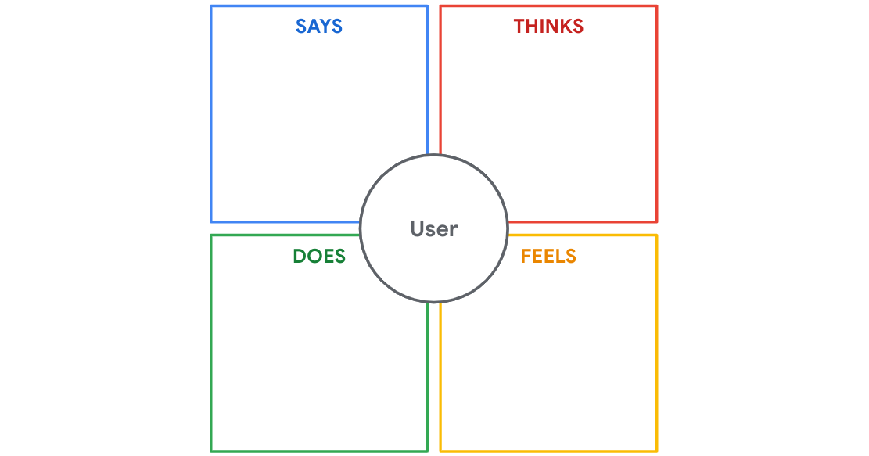

To learn more about the different kinds of empathy maps, check out this article on [empathy mapping](https://www.nngroup.com/articles/empathy-mapping/) from the Nielsen Norman Group.

Pain points

Pain points are any UX issues that frustrate the user and block the user from getting what they need.

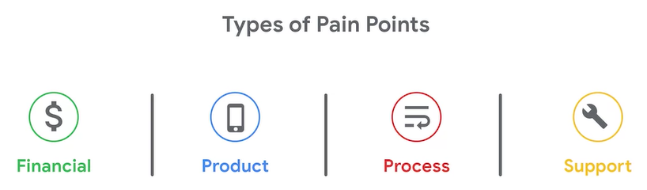

Personas

Personas are fictional users whose goals and characteristics represent the needs of a larger group of users.

A user group is a set of people who have similar interests, goals, or concerns.

Each persona you create humanizes a user group for your team.

You need a set of personas. All user groups should be vividly represented.

Generally, creating 3 to 8 personas is enough to represent the majority of a product’s user base.

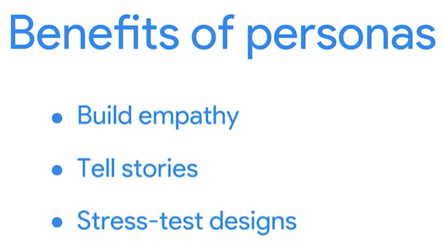

A persona example

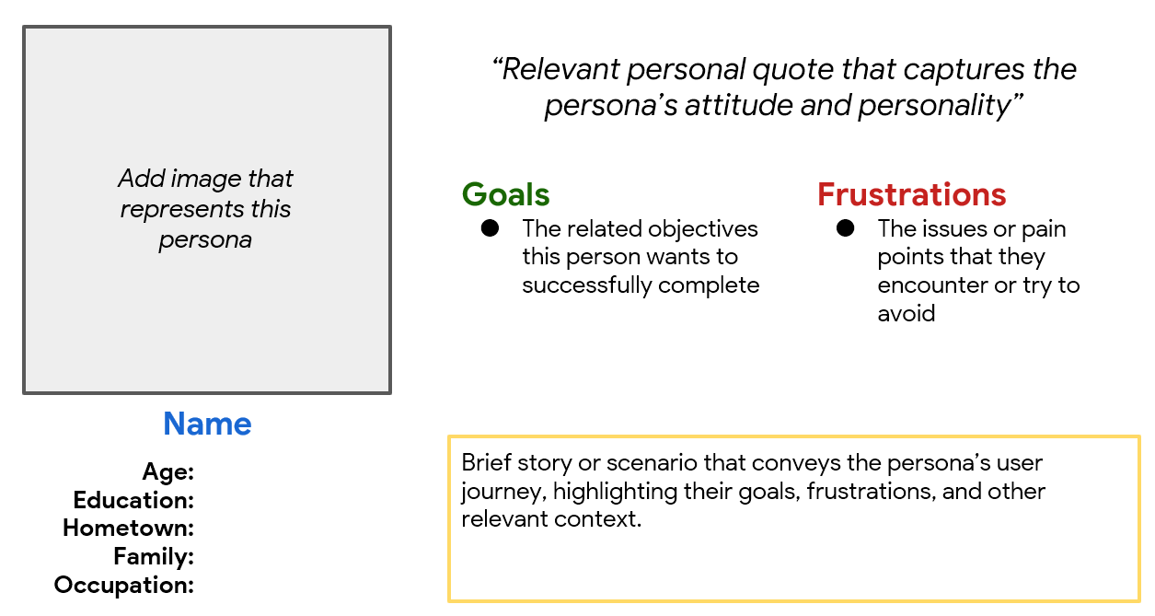

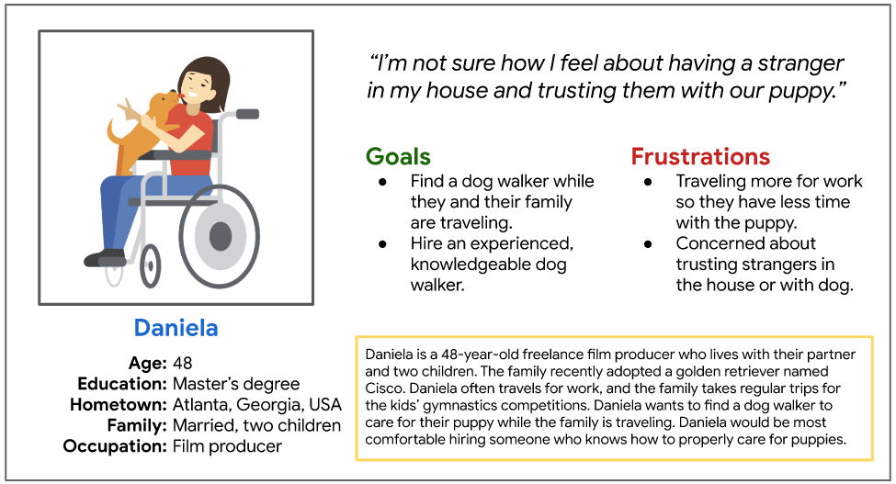

There are many ways you can create personas. You can explore a variety of persona templates like these [persona templates and examples](https://www.justinmind.com/blog/user-persona-templates/) from Just In Mind and these [customizable persona templates](https://xtensio.com/user-persona/) from Xtensio.

If you want to learn even more, check out this [introduction to personas](https://www.interaction-design.org/literature/article/personas-why-and-how-you-should-use-them) from Interaction Design Foundation.